**Reset Page Design**

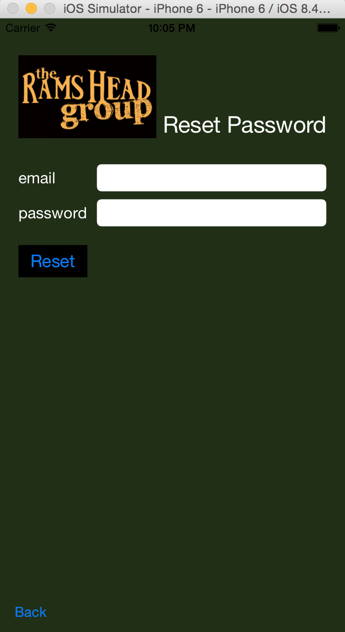**Elements:**

Background: dark green(the same as the website)

Company logo: on the up-left corner, 150x90

Page title: “Login/Register”, white, size 27

“email” label, “password” label: white, size 17

“email” input text field: size 14, email keyboard, Q4

“password” input text field: secure text entry

“reset” button:

black background, blue font, segue to list page

“Back” Button:

segue back to the login/register page.

